PYTHON Variables

Variables in python

Variables are containers for storing values;

**Creating Variables:**

In python there is no command to create a variable;

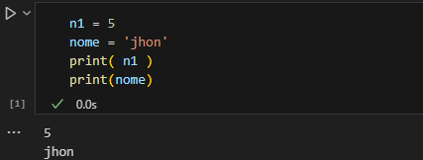A variable is created when you assign some value to it using '='

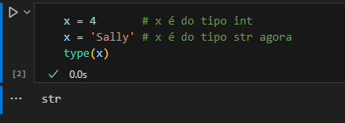Variables don't need to be declared with their type*,*  you can change their *type* at any time as long as you don't do it multiple times;

**CASTING**

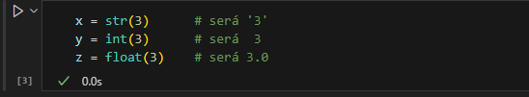If you want to declare the primitive type of a variable, you can.

Cast is a technique of converting the types of an object; If you want to subtract from an object of type 'str' with another object of type 'int' it will not be possible, so you will have to convert str to int.

**GET THE TYPE**

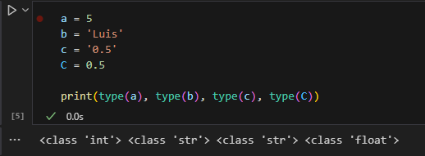You can get the primitive type of the variable using the type*() function*:

Remember that python is case-sensitive, that is, it differentiates between uppercase and lowercase;

**VARIABLE NAMES**

A variable can have a short name such as (x, y, z) or a descriptive name such as (age, name, street). The rules of python are:

* A variable must start with a letter or underscore (_);
* A variable cannot start with a number;
* A variable can contain only alpha-numeric characters and underscores (A-z, 0-9 and _);
* Variables are case-sensitive
* 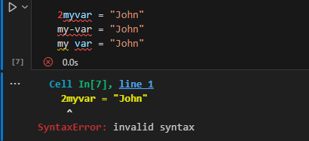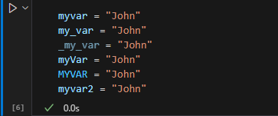Can't be any python keywords

**ASSIGN MULTIPLE VALUES**

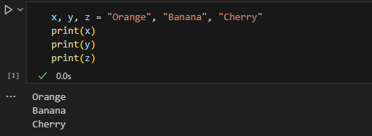 Python allows you to assign values to more than one variable in a single line of code;

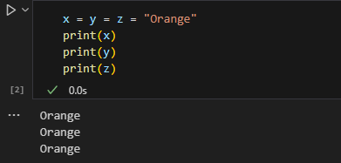In addition, you can assign the same value to different variables in a single row:

**UNPACKING A COLLECTION**

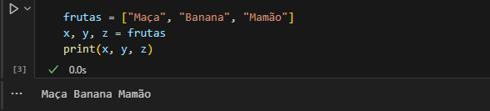If you have a collection of values in a list, tuple, etc., python allows you to extract those values into variables. We call this unpacking.

**OUTPUT VARIABLES**

In python, output variables refer to the variables that store or maintain the result of a program execution.

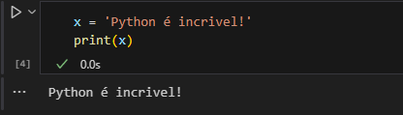The print() function is commonly used as a variable output:

We can use commas to print multiple variables on a single line, or + to concatenate in case of 'str' or sum in case of numeric.

**GLOBAL VARIABLES**

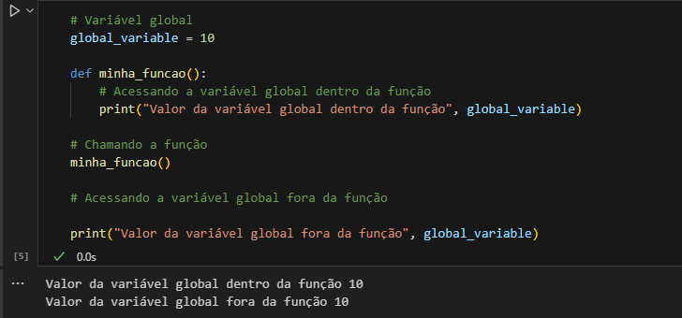 Global variables are those defined outside of any specific function or block of code, and therefore can be accessed from anywhere in the program. All of the above examples are global variables;

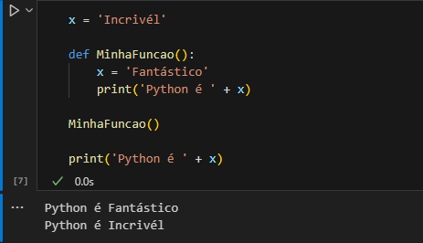If you create a variable within the function with the same name as the global one, this variable can only be accessed within the function. The global variable with the same name will remain active and with the same value set originally;

**THE GLOBAL KEYWORD**

Normally, when you create a variable within a function, it is local and can only be used within that function.

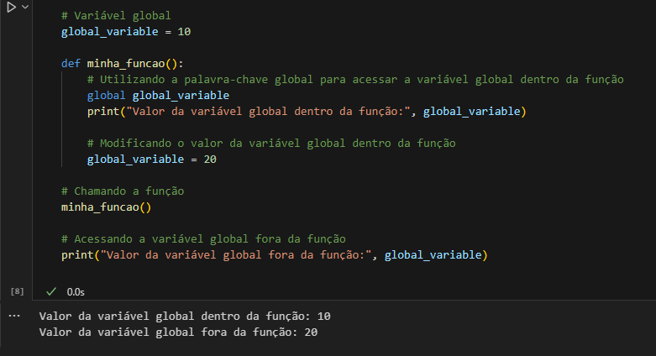But to create a global variable inside a function, you must use the keyword "global"

As shown in the example above, when we create a global variable, call it into a function, use the global keyword and change its value, this change is not restricted only to the inside of the function, but to the entire program.